# Background

## Lesser Prairie Chicken

The Lesser prairie chicken (*Tympanus pallidicinctus*) is a species of grouse native to regions of Colorado, Kansas, Oklahoma, Texas, and New Mexico. Throughout their range, Lesser prairie chicken (LPC) require a mixture of sagebrush, native grass prairie, and shrublands. The current distribution of the species is approximately only 10% of its historical range, due primarily to loss and fragmentation of habitat as the result of conversion to agricultural land, and invasive plant species. LPC habitat can also be degraded by energy development, due to the species’ avoidance of tall structures – a behavior adapted to avoid aerial predators[1]. In 2013, a range wide conservation plan (RWP) was developed to provide voluntary minimization and mitigation strategies for private landowners and industry in an effort to void listing. However, Lesser prairie chicken was listed as a threatened species under the Endangered Species Act (ESA) on March 27, 2014[2], at which point enrollment in the RWP became mandatory for regulated entities. A court ruling on September 1st, 2015 overturned this decision, and the LPC was removed from the endangered species list in April 2016, and the mitigation and impact minimization programs under the RWP have reverted to purely voluntary efforts. The purpose of this analysis was to quantify the extent of energy development and habitat loss occurring since delisting, using a combination of publicly available data and remote sensing.

## Remote Sensing

Remote sensing describes the use of satellite data to describe and measure patterns of land cover and land use. A recent proliferation of available satellite data has increased the ability for remote sensing to be used in conservation work. Presents a significant advance in the ability to monitor and quantify habitat loss. New images become available about every two weeks – and satellites measure beyond the visible spectrum, including infrared and ultraviolet values, providing a greater ability to distinguish land cover types and features than a simple picture.

In our analysis of LPC habitat loss, we used Google Earth Engine - a platform providing access to terrabytes of real time satellite data, and the cloud computing capabilities to analyze them – to create an automated process to detect disturbances and habitat loss. The basic overview of the process is:

1. Acquire ‘before’ and ‘after’ satellite data
2. Calculate changes in reflectance values
3. Select pixels exceeding reflectance change thresholds
4. Distinguish man-made vs. natural changes

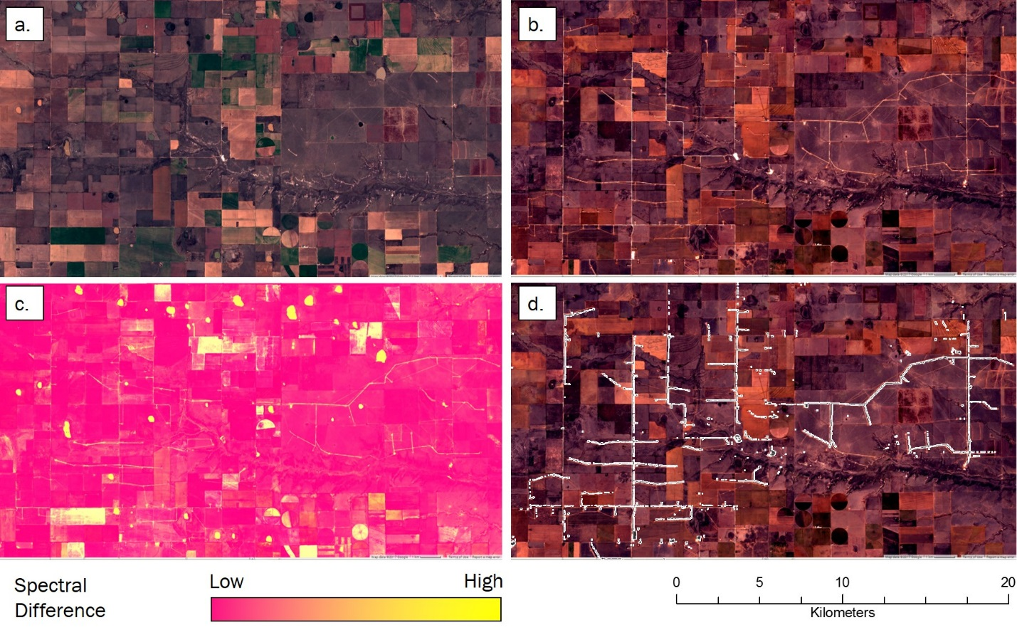

We applied this procedure across the entire LPC range to detect new wind turbines, oil and gas wells, and habitat conversion to agriculture occurring since the species was delisted.

# Findings

## Wind Energy Development

Using our automated change detection procedure, we identified 5 wind farms with a total of 713 turbines constructed after September 1st, 2015 within LPC range. The LPC range wide plan uses a buffer of 667m around turbines to determine the area for which mitigation is needed. Under the RWP, construction of these 713 turbines would create 129,739 acres of potential mitigation area. Furthermore, Lesser prairie chickens’ avoidance of tall structures extends as far as 1 mile, and this area surrounding wind turbines is considered disturbed, or degraded habitat[3]. Considering a 1 mile buffer, these turbines create 257,577 acres of habitat disturbance for LPC.

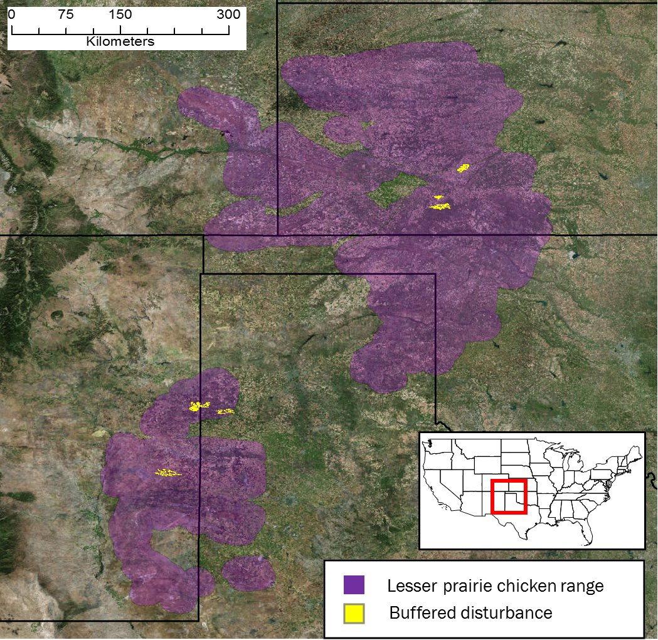

## Oil and Gas

Oil and gas drilling permits and well records are maintained by state oil and gas commissions, including project start dates and well locations. In theory, these records could be used to measure the amount and location of disturbances within LPC habitat due to oil and gas drilling. We obtained the coordinates for 378 new wells reported between September 1st 2015 located within LPC range, and verified the construction of a new well using before and after satellite imagery where available. Only 178 records (57%) that we inspected showed new wells within 500m of the reported location.

|  |  |  |  |  |
| --- | --- | --- | --- | --- |
| **STATE** | **Wells Reported** | **Wells Inspected** | **New Wells Detected** | **Detection Rate** |
| CO | 1 | 1 | 1 | 100% |
| NM | 63 | 25 | 23 | 92.0% |
| TX | 132 | 105 | 49 | 46.7% |
| KS | 163 | 163 | 46 | 28.2% |
| OK | 19 | 16 | 3 | 18.7% |
| **TOTAL** | **378** | **310** | **178** | **57.4%** |

These discrepancies could be caused by errors in recording dates and/or coordinates, unreported changes in project timelines, or in many cases, vague dates reported by the states. For instance, Kansas provides a ‘Year Start’ for well records, which leaves the actual date at which a new well is constructed ambiguous. New Mexico, on the other hand, reports a ‘Spud date,’ the date on which ground was broken when drilling a new well. We confirmed new wells at 92% of reported locations that were checked in New Mexico, but only 28% of those in Kansas.

Additionally, applying our change detection algorithm across LPC range identified 179 new well pads that appeared in LPC habitat since delisting, which did not correspond to any coordinates provided by the states (> 500m from any reported location). The LPC range wide plan uses a buffer of 200 meters around oil and gas wells to determine the area for which mitigation is needed. The 178 reported wells we identified create 3,150 acres of potential mitigation area, after discounting the areas around wells built in already degraded habitat. The 179 wells we identified, which were not associated with oil and gas commission records, created an additional 5,800 acres of potential mitigation area.

## Habitat Loss

In addition to the addition of disturbances, we wanted to estimate the overall loss of LPC habitat across the species’ range since delisting. The majority of this is from conversion of native grass prairie and shrubland to agriculture. Using a measure of vegetation intensity, we identified ### acres that had been converted from LPC habitat in the growing season (April – October) of 2015 to agricultural land in the growing season of 2016.

In total, we estimate a total of ### acres of LPC habitat was disturbed or lost since the species was delisted. In our selection of thresholds across all analyses, we applied a conservative approach, meaning our estimates likely represent the minimum number of disturbances and amount of habitat loss occurring during that time.

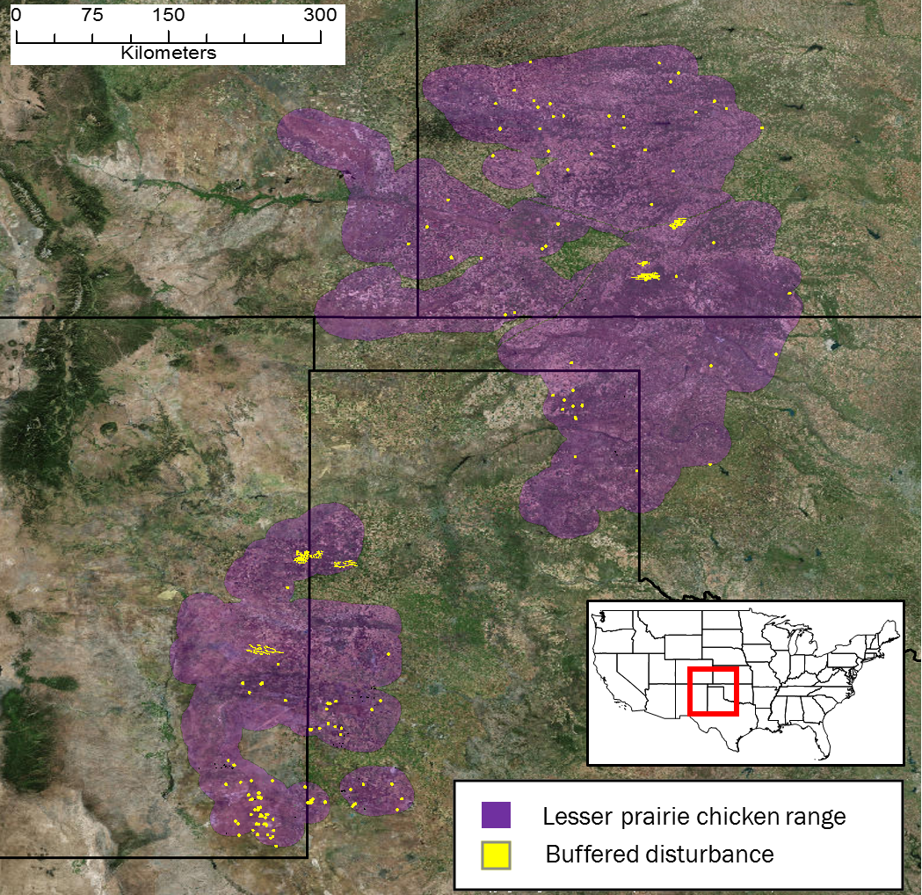

# Methods

## Satellite data

We utilized pre-processed Sentinel-2 imagery available on Google Earth Engine to conduct change detection analyses. To avoid the potential for phenology to confound true land cover change, we selected Sentinel-2 scenes across LPC range acquired outside of the growing season (November to March) in 2015 and 2016. We applied a cloud filter to each image using the QA band, and created a single image composite selecting the median value of each pixel stack.

## Change Detection Algorithm

Our automated change detection algorithm built on methodology used by the U.S Geological Survey to produce the National Land Cover Dataset (NLCD) land cover change data. We calculated four spectral change metrics between before and after imagery, using the Red, Green, Blue, Near Infrared, and Short-wave Infrared bands. The change vector (CV) measures total difference in reflectance values across the visible and infrared spectrum, and relative CV max is the total of each, normalized to its global maximum. Ratio normalized difference soil index (RNDSI), and the normalized difference vegetation index (NDVI) utilize ratios between the to indicate the concentration of bare soil and vegetation, respectively. Pixel values for each change metric were converted to z-scores representing the likelihood of land cover change relative to the global means for normalized indices (NNDSI & NNDVI), and global minimums for scaled indices (CV and RCVmax). All calculations and transformations were performed in Google Earth Engine.

## Change Validation

Due to the distinct pattern of wind farms, we were able to identify new farms by examining the change . We then visually inspected the most recent available Sentinel 2 imagery at new wind farm locations to identify and mark individual turbines. To define change metric thresholds that identified conversion to wind turbine, oil, and gas pads, we performed linear discriminant analysis on these z-scores using a set of 100 validation plots. Plots were selected by visual inspection of the change metric image, and delineating areas with high change likelihoods at which spectral changes did and did not correspond to . From this data, we produced a receiver operating characteristic (ROC) curve to select an LDA score threshold maximizing the second derivative (i.e., rate of change in curve slope). We then converted areas meeting or exceeding this threshold to polygons.

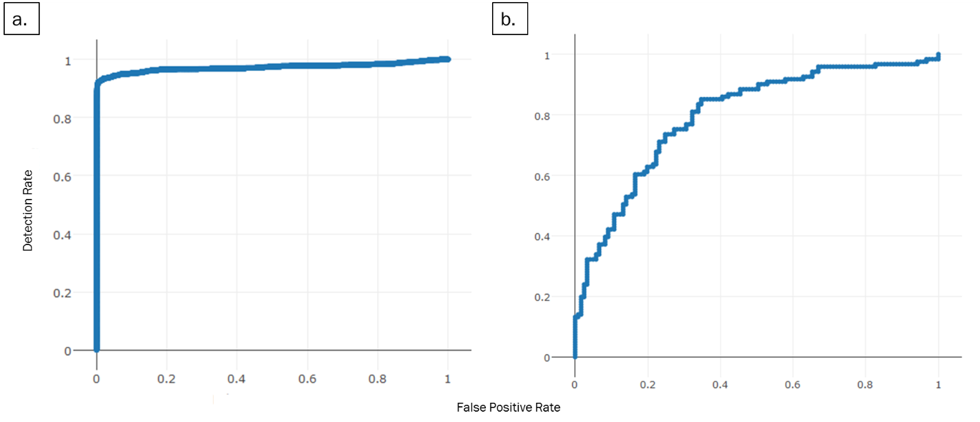

To discriminate between natural landcover changes and human disturbances, we calculated a suite of shape metrics for each of these land cover change polygons. Shape metrics included convexivity, circularity, elongation, and compactness. Each metric was calculated for all disturbance polygons, in addition to disturbance area, and we manually classified a validation set of 400 polygons. As with reflectance threshlds, we used LDA and ROC curves to identify threshold values (Figure ##b). To be conservative, we selected a value. We then visually confirmed each polygon meeting spectral and shape thresholds as being a likely well pad by visually examining before and after Sentinel 2 satellite imagery. For each choice of threshold value at each step was less than one, and therefore eliminated a small set of true human disturbances. Thus, the results reported represent a lower bound for the minimum number of new pads.

We further restricted this set to changes occurring within areas identified as shrub/scrub, or grassland by the NLCD 2011 classifications, thus eliminating disturbances occurring within already degraded habitat (i.e. agriculture) from further consideration. The LPC RWP requires a buffer distance of 200m around oil and gas wells to determine mitigation acreage. To estimate lost potential mitigation opportunities, we applied this buffer to the final set of identified well disturbances. We eliminated buffered areas within which disturbances were already present (Figure ##a), as these could have potentially already been mitigated, or would constitute degraded habitat, and thus be subject to discounted mitigation acreage. Estimated potential was calculated as the total acreage of all remaining buffered areas.

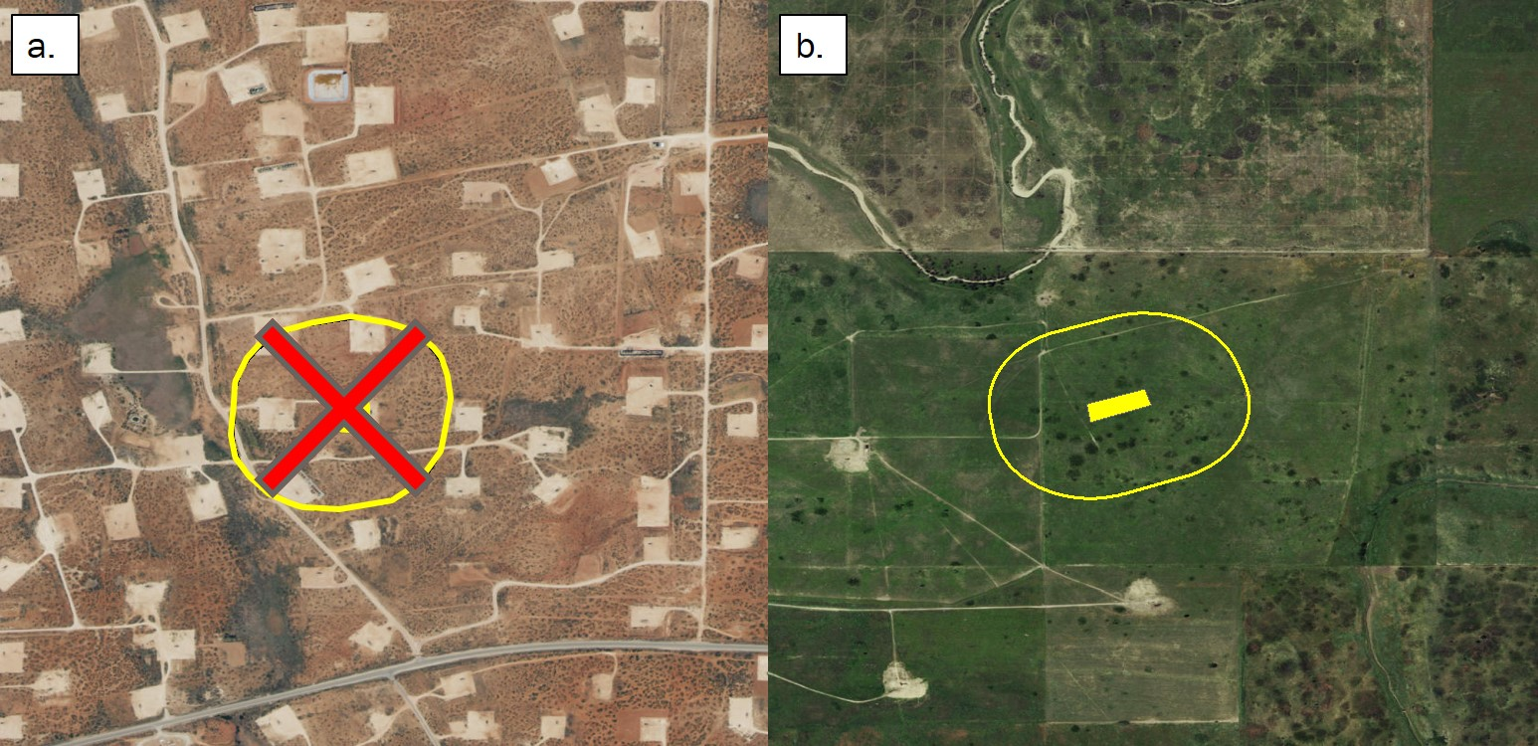

1.
2. U.S. Fish and Wildlife Service, Determination of threatened status for the Lesser prairie chicken; Final Rule April 10, 2014
3. Listing decision